Desserts

Original Beans dark chocolate and Tellicherry pepper mousse, white chocolate and carom crumble, shatkora lime marmalade £14.00
Taylors, Tawny 20 years, Portugal, Glass 100ml £14.00
Malai Kulfi – Old Delhi favourite, served with quinoa and raspberry crumble £9.50
Saussignac, Vendange d’Autrefois, Gascony, France, 2015, Glass 100ml £7.50

Sticky ginger toffee pudding with cinnamon ice cream £8.75
Malvasia Passito , Vigna del Volta, Emilia-Romagna Italy, 2009 Glass 100ml £16.50

Lemon and ginger brulee, pink peppercorn crisp £9.00
Côteaux du Layon St Aubin, Domaine des Barres Loire, France, 2014
Glass 100ml £7.50

Salted caramel tart, wild berry sorbet, poppy seed meringue £9.50
Enamor Yuzu liqueur de France Glass 50ml £8.30

Saffron poached pear, sago and pineapple payasam, roasted plum sorbet (vegan) £10.00
Muscat de Frontignan, Chateau de Peysonnie, France, Glass 100ml £8.00
Ice cream or sorbet selection of the day £7.50
Franciacorta Brut Castelveder, Italy, Glass 125ml 11.40
Selection of Neal’s Yard cheeses with quince chutney £14.50
Fonseca, Vintage port 2001, Portugal, Glass 100ml £12.60

Dessert Platter
Tasting plate of assorted desserts – for two or more
£30.00 per two people
NV Champagne Brut Rosé Francois Monay
Bottle 750ml £77.00 Glass 125ml £15.40

We welcome your comments and suggestions.
Please speak to our Duty Manager or e-mail us at info@cinnamonclub.com
Please be considerate when using mobile phones.
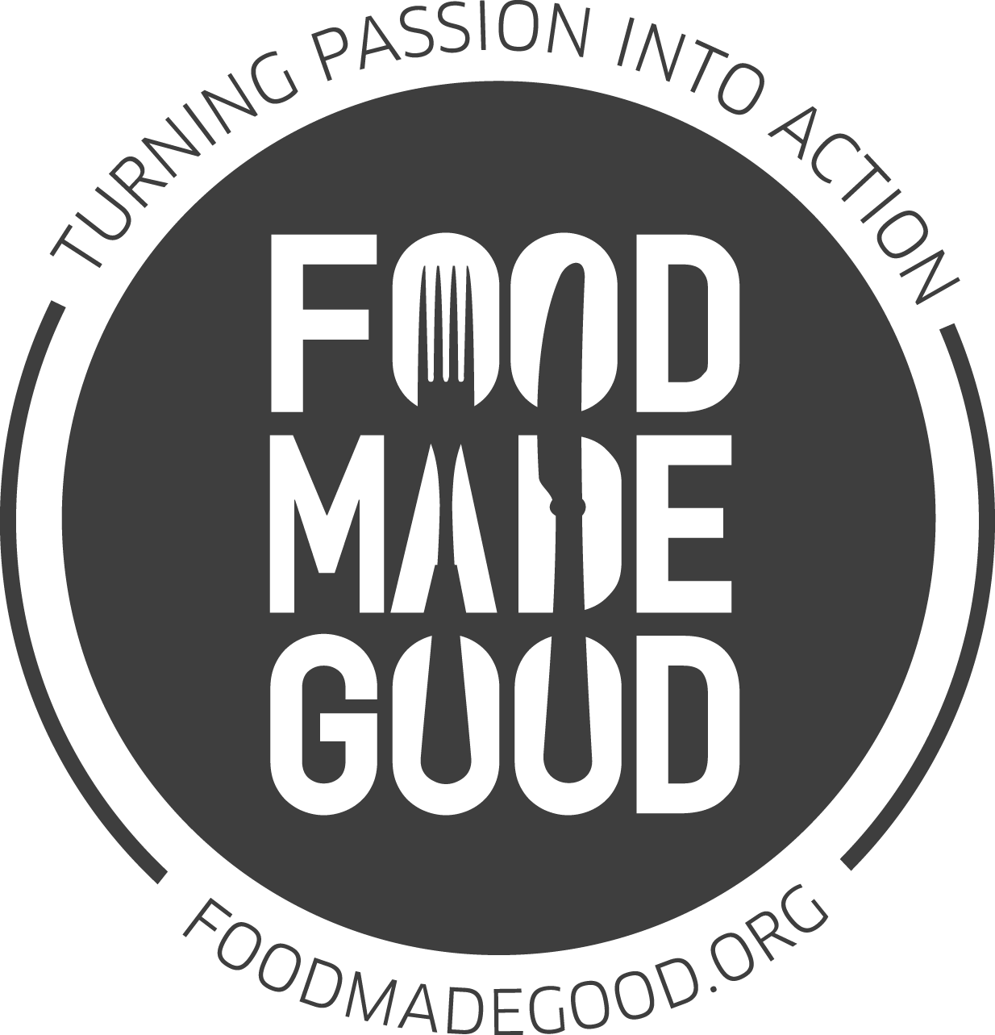

The Cinnamon Club are
long-standing SRA members and are
involved in a range of sustainability efforts.

(v) Vegetarian Contains gluten Allergen menus available on request.
Prices include VAT @ 20%. We do not levy service charge for tables of up to 8 people. Please inform one of our team of your specific allergy or dietary requirement when ordering. Our suppliers and kitchens handle numerous ingredients and allergens. Whilst we have strict controls in place to reduce the risk of contamination, unfortunately it is not possible for us to guarantee that our dishes will be 100% allergen or contamination free. We import all our spices directly from approved growers across India. Our food suppliers have given assurances that none of our ingredients are genetically modified. Fish may contain small bones. Game dishes may contain shot.

Tasting Menu
£95 per person, £180.00 with premium wines
To maximise your dining experience, this menu must be ordered by each diner at your table

Appetisers

Tandoori Norfolk free range chicken chaat in pastry shell
Devon crab and kokum berry salad on lotus root crisp
Stir fry of shrimps with curry leaf and ginger
Muscadet de Sèvre et Maine sur Lie ‘Schistes de Goulaine’
Domaine R de La Grange, Loire, France, 2010

First Starter

Carpaccio of home cured Shetland salmon and caramel jhal muri
Riesling Rheinschiefer, Peter Jakob Kühn, Rheingau Germany, 2015

Second Starter

Tandoori long legged partridge breast with green spices, kachri chutney
Château Pavillon Beauregard, Lalande-de-Pomerol, Bordeaux, France, 2016

Rest course
Pressed watermelon chaat, pineapple granita, ginger and coconut foam

First Main Course

Char-grilled monkfish with Kerala curry sauce
Muscat Sec Cave des Vignerons de Frontignan VDP d‘Oc, France, 2017

Second Main Course
Balmoral Estate venison loin, black stone flower reduction
Or
Raan - Braised shoulder of milk fed Cumbrian lamb, nutmeg and fennel sauce
Barolo, Dacapo, Serralunga, Piedmonte, Italy, 2010

Dessert

Lemon and ginger brûlée, pink peppercorn crisp
Château Caillou, Second Cru Classé, Barsac, Sauternes France, 2011

Coffee and Petits Fours
Served in the Old Library Bar

Contains gluten (v) Vegetarian Allergen menus available on request.
Prices include VAT @ 20%. We do not levy service charge for tables of up to 8 people. Please inform one of our team of your specific allergy or dietary requirement when ordering. Our suppliers and kitchens handle numerous ingredients and allergens. Whilst we have strict controls in place to reduce the risk of contamination, unfortunately it is not possible for us to guarantee that our dishes will be 100% allergen or contamination free. We import all our spices directly from approved growers across India. Our food suppliers have given assurances that none of our ingredients are genetically modified. Fish may contain small bones

Starters
Grilled tenderstem broccoli, rose petals, spiced almond flakes (v) £9.00

Tandoori octopus with chutney aloo, fennel salad and tomato lemon dressing £13.00
Char-grilled organic kingfish with carom seed, carambola pickle £11.50

Tandoori long legged partridge breast with green spices, kachri chutney, beetroot raita, pickled walnut and raisin £18.00
Sandalwood flavoured Norfolk free range chicken, chicken tikka rillettes £11.00
Smoked Herdwick lamb fillet and galouti kebab mille feuille £12.50
For those challenged on the spice front, The Cinnamon Club is pleased to showcase
dishes by our friend, the critically acclaimed chef Eric Chavot:
Crab risotto with truffle cappuccino, pan fried king prawn £14.50
As a main course £29.00

Main Courses

Tamil style butternut squash in garlic confit curry, Gobindobhog khichri (v) £22.00
Char-grilled monkfish with Kerala curry sauce, tomato rice £29.00
Wild Spencer Gulf king prawns with Allepey curry sauce, rice vermicelli £35.00
Tandoori free range chicken breast with rich onion crust, pickling sauce, toasted buck wheat and brown lentils £22.50

Roast saddle of Romney Marsh lamb, sesame and tamarind sauce, keema palak, pickled root vegetables £29.50
Balmoral Estate tandoori venison loin, black stone flower reduction and fenugreek potatoes £38.00
Eric’s Main: Seared rump steak of 28 day dry-aged Hereford beef, fondant potatoes, red wine sauce £32.00

Sharing Mains
Served tableside
Old Delhi style butter chicken on the bone, black lentils, pilau rice and garlic naan £70.00 (for two)
Whole rack of Romney Marsh lamb, saffron-roganjosh sauce, black lentils,
pickled vegetables and hot garlic chutney £85.00

(v) Vegetarian Contains gluten Allergen menus available on request.
Prices include VAT @ 20%. We do not levy service charge for tables of up to 8 people. Please inform one of our team of your specific allergy or dietary requirement when ordering. Our suppliers and kitchens handle numerous ingredients and allergens. Whilst we have strict controls in place to reduce the risk of contamination, unfortunately it is not possible for us to guarantee that our dishes will be 100% allergen or contamination free. We import all our spices directly from approved growers across India. Our food suppliers have given assurances that none of our ingredients are genetically modified. Fish may contain small bones. Game dishes may contain shot.

The Cinnamon Set Lunch
£27.50 for two courses
£4 supplement for third course
Add half a bottle of our wine, hand-selected by our sommelier for £15.00
Starters
Bombay style vegetables with truffled pao, Jerusalem artichoke crisp (v)
Bengali spiced fish cake with beetroot and raisin, kasundi mustard
Stir-fry of chicken legs with mint and molasses, pineapple raita
Main Courses
Banana chilli filled with fenugreek, raisin and bitter gourd, green pea pilau
and yoghurt sauce (v)
Shrimp crusted coley fillet, green curry sauce steamed basmati rice
Rajasthani style goat and green chilli kofta with corn and yoghurt sauce, pilau rice
Double cooked Koorgi pork with kokum berries, masala cashew nut, curry leaf and lime crumble
Desserts
Sorbet selection of the day
Prune, ginger and pumpkin pudding, roasted plum sorbet
Key lime pie with fennel ice cream
Selection of Neal’s Yard cheeses with quince chutney
£8.00 supplement

Side Dishes
Rajasthani sangri beans with fenugreek and raisin £8.00
Black lentils £6.50
Cabbage and seasonal green foogath with coconut £5.75
Home style split yellow peas with cumin £5.00
Aloo Gobi – Punjabi style stir-fried potato and cauliflower £6.50
Tomato and curry leaf quinoa £5.50
Garlic naan £4.00
Potato stuffed paratha £4.00
Selection of breads £8.00
Selection of chutneys £5.50

