Desserts

Chocolate chilli praline fondant, hazelnut mousse, banana peanut ice cream £14.00
Taylors, Tawny 20 years, Portugal, Glass 100ml £14.00
Royal Punjabi kulfi, honeycomb pistachio crumble £9.50
Saussignac, Vendange d’Autrefois, Gascony, France, 2013, Glass 100ml £7.50

Mithai chaat – collection of Indian festive sweets £11.50
Rice kheer, ras malai, shrikand sorbet, boondi and pop corn
Piccolit, Aquila del Torre, Friuli, Italy, 2004, Glass 100ml £13.50

Lemon and ginger brulee, masala sable £9.00
Côteaux du Layon St Aubin, Domaine des Barres Loire, France
Glass 100ml £7.50

Garam masala pudding, cinnamon custard£9.50
Malvasia Passito Vigna del Volta, Romagna, Italy, 2009, Glass 100ml £16.50

Gulab jamun and yuzu tart, iced double cream £9.50
Tokaji Szamorodni Szepsy, Hungary, 2012, Glass 100ml £20.00

Saffron poached pear, tapioca and lime payasam £10.00
Muscat de Frontignan, Chateau de Peysonnie, France, Glass 100ml £8.00

Ice cream or sorbet selection of the day £7.50
Selection of Neal’s Yard cheeses with quince chutney £14.50
Taylor Tawny 10 years, Portugal, Glass 100ml £9.00

Dessert Platter
Tasting plate of assorted desserts – for two or more
£30.00 per two people
NV Champagne Brut Rosé Premier Cru Nicolas Guesquin
Bottle 750ml £74.00 Glass 125ml £15.00

We welcome your comments and suggestions.
Please speak to our Duty Manager or e-mail us at info@cinnamonclub.com
Please be considerate when using mobile phones.
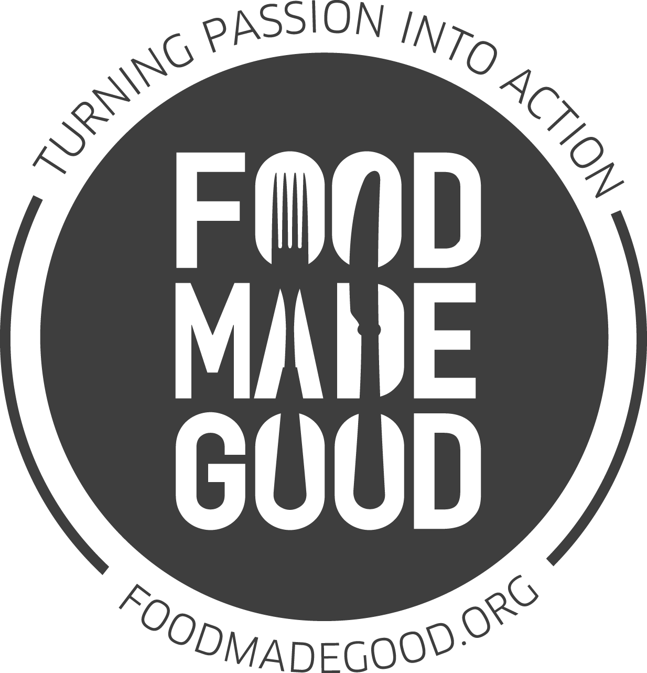

The Cinnamon Club are
long-standing SRA members and are
involved in a range of sustainability efforts.
Our king prawns are wild-caught and MSC certified

(v) Vegetarian Contains gluten Allergen menus available on request.
Prices include VAT @ 20%. We do not levy service charge. Some of our dishes may contain or have been in contact with nuts, please let your server know of any allergies or dietary requirements. We import all our spices directly from approved growers across India. Our food suppliers have given assurances that none of our ingredients are genetically modified. Fish may contain small bones. Game dishes may contain shot.

Tasting Menu
£95 per person, £180.00 with premium wines
To maximise your dining experience, this menu must be ordered by each diner at your table

Appetisers

Tandoori Norfolk free range chicken chaat in pastry shell
Devon crab and kokum berry salad on lotus root crisp
Carpaccio of home cured Shetland salmon and caramel jhal muri
Nevina Vinograd Sv, Domaine Saint Hills, Istria, Croatia, 2013

First Starter

Kerala spiced seafood bisque flamed with brandy
Isake Classic, Junmai Ginjo, Hyogo, Japan

Second Starter

Okra filled with peanut and jaggery, green mango chutney
Pithod – chickpea and yoghurt gnocchi
Banana chilli filled with fenugreek, raisin and bitter gourd
Riesling Kabinet Trocken, Weingut Familie Rauen, Germany, 2016

First Main Course

Wild Spencer Gulf king prawns with mango coriander sauce
Oasi, Aquila del Torre, Friuli, Italy, 2011

Second Main Course
Tandoori loin of Balmoral Estate venison, black stone flower reduction

Aloxe-Corton, Domaine de a Galopiere, Burgundy France, 2008.

Dessert

Saffron poached pear, tapioca and lime payasam
Prucia Plum Liquer De France

Coffee and Petits Fours
Served in the Old Library Bar

Contains gluten Allergen menus available on request.
Prices include VAT @ 20%. We do not levy service charge. Some of our dishes may contain or have been in contact with nuts, please let your server know of any allergies or dietary requirements. We import all our spices directly from approved growers across India. Our food suppliers have given assurances that none of our ingredients are genetically modified. Fish may contain small bones. Game dishes may contain shot.

Starters
Okra filled with peanut and jaggery, curried yoghurt and green mango chutney (v) £10.00

Tandoori octopus with chutney aloo, fennel salad and tomato lemongrass dressing £11.00
Fenugreek scented tandoori cod, curry leaf and lime crumble £11.50
Norwegian king crab with spiced shallot crust, crab and tamarind salad, coconut galangal sauce £30.00

Tandoori pigeon, pumpkin chutney, minced leg and juniper berry roll, cucumber raita £18.00
Sandalwood flavoured Norfolk free range chicken, chicken tikka rillettes £11.00
Smoked Herdwick lamb fillet and galouti kebab mille feuille £12.50
For those challenged on the spice front, The Cinnamon Club is pleased to showcase
dishes by our friend, the critically acclaimed chef Eric Chavot:
Crab risotto with truffle cappuccino, pan fried king prawn £14.50
As a main course £29.00

Main Courses

Banana chilli filled with fenugreek, raisin and bitter gourd, green pea pilau
and yoghurt sauce (v) £21.00

Seared sea bass fillet on spiced red lentils, coconut ginger sauce and puffed buckwheat £22.50
Char-grilled halibut with yoghurt kadhi, tomato rice £29.00
Wild Spencer Gulf king prawns with mango coriander sauce, rice vermicelli £35.00
Tandoori Norfolk free range chicken breast in Hyderabadi korma sauce, garlic naan crumble £22.50
Roast saddle of Romney Marsh lamb, saffron-roganjosh sauce, pickled root vegetables £29.50
Tandoori loin of Balmoral Estate venison, black stone flower reduction and fenugreek potatoes £39.50
For every dish ordered, we will donate £2 towards Action Against Hunger’s Love Food, Give Food campaign
Eric’s Main: Seared rump steak of 28 day dry-aged Hereford beef, fondant potatoes, red wine sauce £32.00

Sharing Mains
Served tableside
Old Delhi style butter chicken on the bone, black lentils, pilau rice and garlic naan £70.00 (for two)
Whole rack of Romney Marsh lamb, corn and yoghurt sauce, black lentils,
pickled vegetables and hot garlic chutney £85.00

(v) Vegetarian Contains gluten Allergen menus available on request.
Prices include VAT @ 20%. We do not levy service charge Some of our dishes may contain or have been in contact with nuts, please let your server know of any allergies or dietary requirements. We import all our spices directly from approved growers across India. Our food suppliers have given assurances that none of our ingredients are genetically modified. Fish may contain small bones. Game dishes may contain shot.

The Cinnamon Set Lunch
£27.50 for two courses
£4 supplement for third course
Add half a bottle of our wine, hand-selected by our sommelier for £15.00
Starters
Spiced aubergine and cauliflower fritters, tamarind barley, corn purée & masala toasted seeds (Vegan)
Bengali style cod and beetroot cake, kasundi mustard and chilli mayo
Sandalwood flavoured tandoori chicken breast, chicken tikka rillettes
Clove smoked Kentish lamb escalope, green coriander chutney, sprouted moong raita
Main Courses
Roast courgette filled with tamarind glazed vegetables, yellow lentils with coconut, tomato rice (Vegan)
Pan seared hake fillet, Alleppey curry sauce, spinach poriyal
Chettinad style curry of free range chicken legs, steamed basmati rice
Venison seekh kebab, black lentils, pilau rice and smoked paprika raita
Desserts
Sorbet selection of the day
Passion fruit cheesecake, blood orange salsa
Spiced almond halwa, yoghurt and rose crumble, thandai ice cream
Selection of Neal’s Yard cheeses with quince chutney
£8.00 supplement

Side Dishes
Rajasthani sangri beans with fenugreek and raisin £8.00
Black lentils £6.50
Cabbage and seasonal green foogath with coconut and curry leaf £5.75
Home style split yellow peas with cumin £5.00
Aloo Gobi – Punjabi style stir-fried potato and cauliflower £6.50
Keema Karela – lamb mince and bitter melon £10.00
Garlic naan £4.00
Potato stuffed paratha £4.00
Selection of breads £8.00
Selection of chutneys £5.50

